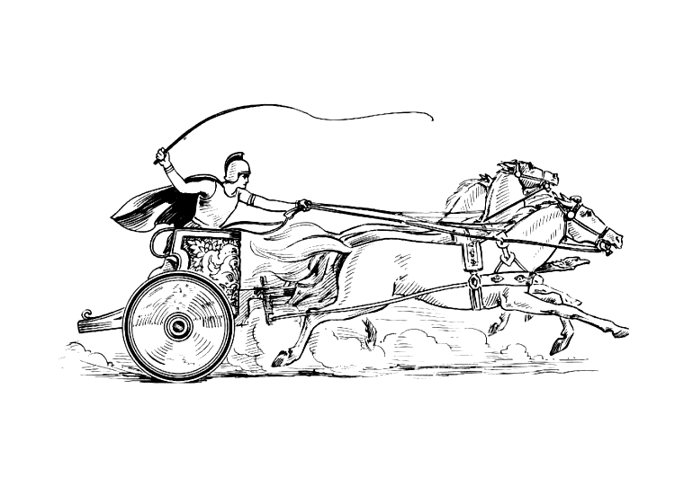Manduessedum - Mancetter Village (Place of War Chariots)
Mancetter Parish Council
Serving the People of Mancetter and Ridge Lane

You are invited to an Extraordinary Parish Council Meeting
to be held in the Schoolroom of St Peter’s Church Mancetter
on Monday 10th February 2025 at 6.30pm.

AGENDA

- Welcome and Apologies.

- Declared notice of interest by Councillors concerning agenda items.

- To review the current allotment rents, waiting list, and authorise the Chairman to collect
payments on behalf of the Parish Council

- PAP/2023/0324 – Outline Access application for the construction of three dwellings to
the rear of the White Hart Inn Ridge Lane. – To formulate the parish council response to
the latest information.
- To consider a revised quotation for soil heap reduction at Mancetter Cemetery.

- Date of next meeting- Tuesday 25th March 2025
7PM Schoolroom St Peter’s Church Mancetter.

Signed 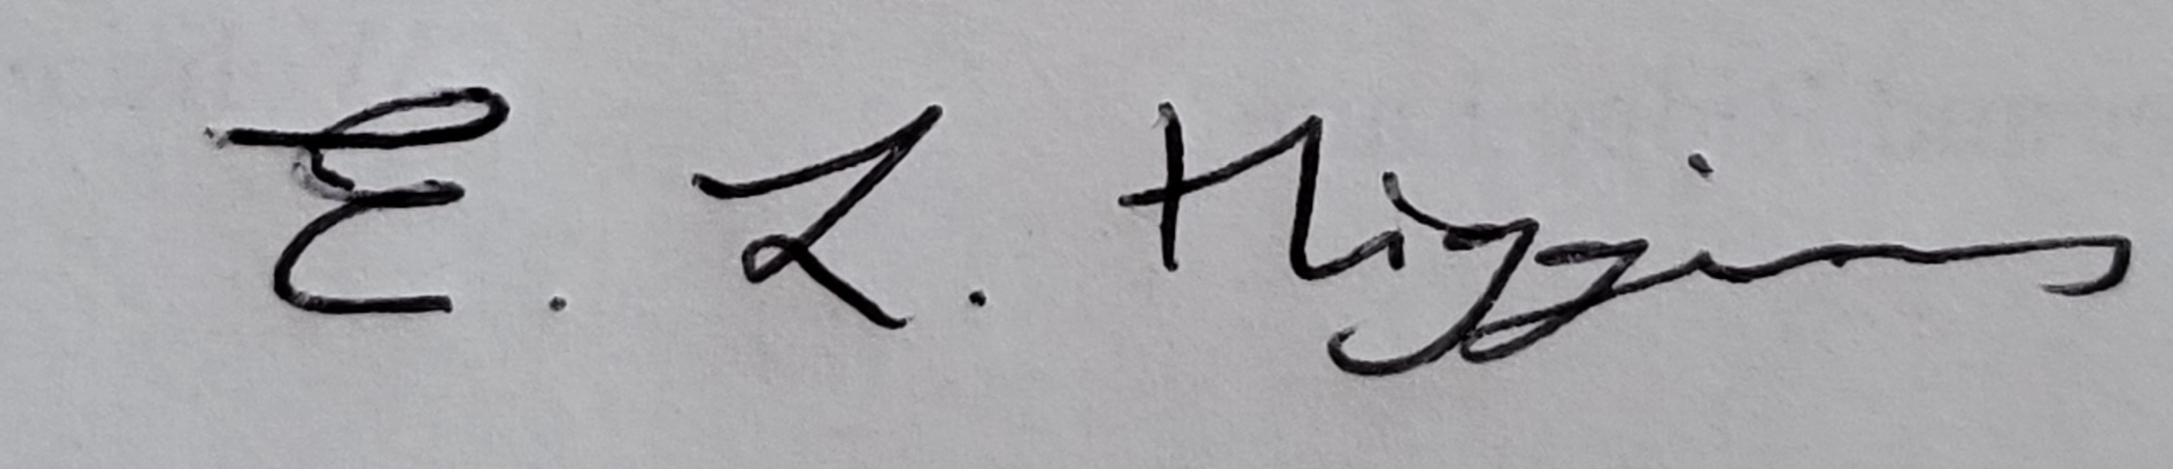
Date 5th February 2025.

Elane Higgins
Parish Clerk Mancetter Memorial Hall Old Farm Road Mancetter CV9 1QN Tel: 01827 722552 Email: parishclerk@mancetterparishcouncil.gov.uk
Website: www.mancetterparishcouncil.gov.uk
Manduessedum - Mancetter Village (Place of War Chariots)
Mancetter Parish Council Serving the People of Mancetter and Ridge Lane

